1. Program to swap 2 numbers(using function)
2. Program to swap 2 numbers(without using 3rd variable)
3. Program to swap 2 numbers(without using arithmetic operation)
4. Program to print 10 prime numbers
5. Factorial using recursion
6. Program to check whether a number is even or odd.
7. Program to check whether a number is prime or not.
8. Program to find maximum and minimum of 3 numbers.
9. Program to accept marks and print GRADE obtained.

|  |  |
| --- | --- |
| MARKS | GRADE |
| ABOVE 80 | A |
| 61-79 | B |
| 41-60 | C |
| 25-40 | D |
| Below 25 | F |

1. Accept 3 sidea of a triangle and check if triangle is possible or not. Also,tell whether the triangkle is equilateral,isosceles or scalene.
2. Create a menu-driven program to calculate area of square, circle and triangle.(Use switch case—“1” for square and “2” for circle , “3” for triangle)
3. Program to accept a number and print sum of digits.
4. Program to check whether it is a palindrome or not.
5. Program to check whether it is a perfect square or not.
6. Program to check whether it is An Armstrong number or not.
7. Program to check whether it is a Perfect number.
8. Program to print Fibonacci series upto “n”.
9. Program to perform Matrix addition.
10. Program to perform Matrix multiplication.
11. Aceept 10 numbers and print maximum and minimum(using array).
12. Program to accept 10 numbers and print even and odd numbers separately.
13. Program to print the following series:-
14. 2+4+6+8+…….n
15. 1+2+4+7+11+16……N
16. 1+11+111+1111+…..N
17. 12 + 32 + 52 …….N
18. 1+22 +33 + 44  +…..n
19. 1-22 / 3! + 32 /5! – 42 /7!+……n

23)Print the following patterns:-

i) *

**

***

****…….n

ii) 4

4 3

4 3 2

4 3 2 1…..n

iii) 4 3 2 1

4 3 2

4 3

4.,….n

iv) 1

2 2

3 3 3

4 4 4 4 …..n

v) 4

4 3 4

4 3 2 3 4

4 3 2 1 2 3 4……n

vi) 4 3 2 1 2 3 4

4 3 2 3 4

4 3 4

4…….n

vii) *

* *

* * *

* * * *

Viii)

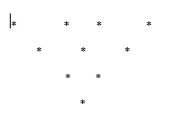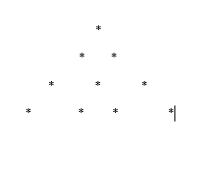

24) Check whether a string is palindrome or not.

25) Extract the said number of digits from a string.

26) Accept a string and count number of characters.

27) Accept a string and print vowels and consonants.

28) 13 /1! + 23 /2! + 33 /3! + 43 /4!.......n terms.